RECEIPT KEEPER – IMPLEMENTING RESTFUL API USING LOOPBACK FRAMEWORK
C. Choi, H. Nahhal, N.Collins, S. Kim
Mobile Solution Developments,

School of Engineering & Information Technology

Conestoga College, ON, Canada

Abstract- One of documents that are frequently met in our daily life is receipt. Receipts can be used for tracking of personal use or should be preserved for tax report or refund purpose. For professional area, employees’ spending during the performing their task should be reported to the account.

Add how we will solve the problem.[Joe]

I. INTRODUCTION

Receipt Keeper will allow users to track how much money they spent in a certain category over a specific number of months, as well as start a group which others can be invited to join, and this will allow group admins to see reports for the group. Receipt Keeper is built to work on Android devices and also include a web app. The mobile application will make it easier for people to manage categories, tags and reports while having the convenience of scanning receipts wherever they are. The web application provides the list of receipts and shows graphs to visualize user’s spending.

A. Challenges and objectives
Biggest challenges to make working product within limited time and limited resources.

1) OCR engine to recognize numbers and characters on user’s receipt: due to lack of knowledge on OCR, open source was considered which are Open CV, Tesseract, etc.

2) Providing Rest API for scalability: A lot of type of devices should be connectable to the server such as web application, Android, iPhone, Tablet, even customized devices. Implementing a Server which is connectable with API is another challenge.

3) Android Application using Rest API to communicate with Server: To implement a working product within a time, team is focusing on implementing

TABLE I. TYPE SIZES FOR PAPERS
Type  Size  (pts.) | Appearance
Type  Size  (pts.) | Regular | Bold | Italic
Type  Size  (pts.) | Section titles,ª references, tables, table names,ª first letters in table captions,ª figure captions, footnotes, text subscripts, and superscripts
Type  Size  (pts.) |  | Abstract
Type  Size  (pts.) | Authors’ affiliations, main text, equations, first letters in section titlesª |  | Subheading
Type  Size  (pts.) | Paper title

II. METHODOLOGIE

A. Development Methodologies & Team Rules
Position figures and tables at the tops and bottoms of columns. Avoid placing them in the middle of columns. Large figures and tables may span across both columns.

- Agile Unified Process:
Every 2weeks Figure captions should be centered below the figures; table captions should be centered above. Avoid placing figures and tables before their first mention in the text. Use the abbreviation “Fig. 1,” even at the beginning of a sentence.

- Coding rule
Coding rule should be minimized to every member can follow the rule and should be updated after members are accustomed to the rule. Coding rule also includes comment rule for Git, JavaScript, and Android.

B. Source Control & Change Management
- GitHub
Three GitHub projects are created for managing document, web server & app, android.

- Rule
Direct commit was discouraged, but encouraged pull request for peer review and made a rule for source code management.

- Sharing Information
To share the information such as coding rule, link information, and minutes, Wiki page at GitHub was used.

C. Issue Tracking
GitHub’s issue tracking function was used to simplify the managing. Although it has not many functionality compared other issue tracking such as Jira, it can be connected with GitHub seamlessly.

D. Backend as a Service (BAAS)s
LoopBack was used

E. Deployment
For supporting interoperation during the development, it is important to set up the server environment early that every member can use. HEROKU provides free account for prototyping. However, one of drawback of free account is server will go into sleep after 30 minutes’ inactivity, so it needs to be activated before using server, but it is not a big problem for prototyping. Moreover, HEROKU supports buildpacks for deploying LoopBack app, so after uploading source code with Git to the HEROKU environment, it will be compiled and deployed automatically.
To avoid the problem of cracking the operation of the server, pipeline features at HEROKU was used. After setting up, every pull request at project’s GitHub will trigger build with source code by HEROKU, it will -> Review App -> Staging -> Production.

Buildpacks is used for deploying LoopBack app

F. Data as a Service (DAAS)
Although if team is getting bigger and bigger, internal customized setting up environment using container such as Docker, is needed. However, to reduce time setting up environment, it was decided to use cloud database service. Because LoopBack does not support cloud database service with free, it was decided to use other database service. Among the provider, mLab is providing Database-as-a Service with various type of plans and features for MongoDB. Among the plans, Sandbox plan provides 500MB with free which is enough for development and prototyping, although it is slow compared to non-free plans.

E. Sharing Issues and Communication
Because team members work in separate place, although one day is allocated for Capstone project lab, it is necessary to set up communication channels other than phone. Slack is a famous messaging app for professional use. Channels were set up for the subject of discussion and have used for the discussion of interoperation or sharing knowledge.
Additionally, to share the information, such as minutes , coding rules, and documentation, GitHub’s Wiki was used because managing many tools or sites can be another burden to the team, GitHub was used as a hub to share the outcome of project.
.

III. ARCHITECTURE DECISIONSITS

Use either SI (MKS) or CGS as primary units. (SI units are encouraged.) Englsh units may be used as secondary units (in parentheses). An exception would be the use of English units as identifiers in trade, such as “3.5-inch disk drive.”

A. Architectural Driver
- Quality Attributes
- Scalability: Extensible to other kind of client
- Flexibility: Easy to change API
- Performance: Quick to search
- Security:

- Architectural Decisions
- REST API
- NO SQL for the speed of search and Node.js
- Security: CORS in middleware

IV. TECHNOLOGIES

Because one of the application’s main feature is to help a user entering receipt by using Optical Character Recognition (OCR) technologies, OCR is main technology that is used.

- Optical Character Recognition (OCR)
Due to lack of knowledge of OCR, team decided to use open source for character recognition. Open CV, Tesseract is the one of consideration. Open CV is a famous computer vision open source, and Tesseract is a famous for OCR. There are a lot of open source project subsidiaries based on Tesseract. Although Open CV was not used for this project, it can be used for pre-processing receipt images such as contrast enhancement, auto tilting of image to enhance recognition rate for OCR engine in the future project.

- LoopBack
Another main technologies is a server to support REST API. Various platforms are considered, but due to lack of team’s skills and to minimize time to implement the server, LoopBack is chosen finally. Table1 is the comparison of features between BAAS (Back end As a Service) solutions.

LoopBack is an open source Node application framework based on Express which is supported by IBM and StrongLoop(Acquired by IBM on September, 2015). It makes easy to create Rest API platform and managing REST API with provided tools, such as creating new API or apply access control list (ACL). Moreover, it has Built-in API explorer to test API which is useful to test the server operation before implementing web client or mobile application.

LoopBack supports a Yeoman-based scaffolding tool for generating new project skeletons, so it takes a few minutes to make skeletons of the project.

LoopBack helps with that further by providing a model generator for building your models quickly. Entity relationships are also very well supported. The security model is also complex with user roles, principals and ACLs

Authentication and authorization are important tasks for implementing a server, but it was easy to setup authentication and authorization by using LoopBack’s built-in role based access controls. Open Standard for Authorization (OAuth) user and registration models is baked in the Loopback, so it is also easy to embedded third party login such as Google, Facebook.

StrongLoop Arc is a graphical tool for building, deploying, managing and monitoring LoopBack applications and APIs.

Developers have a various choice of database connectors for all major SQL databases and MongoDB. LoopBack helps with that further by providing a handy model generator for building your classes quickly. These can be validated with the built-in validation methods. Entity relationships are very well supported. The security model is complex with user roles, principals and ACLs.
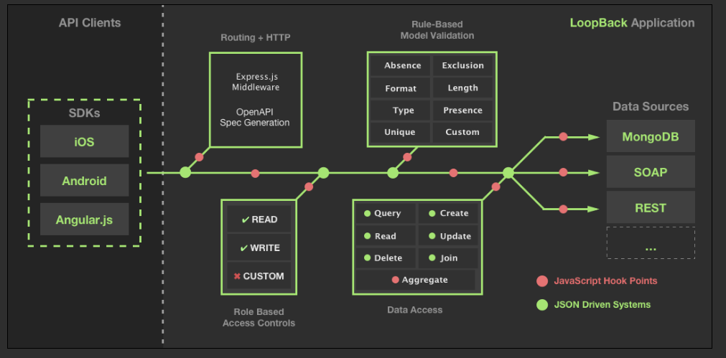
Fig. 1. LoopBack Application

TABLE I. COMPARISON OF BAAS (BACKEND AS A SERVICE)

 | LoopBack | Express | Sails | Restify | Meteor
Type | API framework | HTTP server library | Web MVC framework | REST HTTP library | Full-stack JavaScript app platform
Top Features | Enterprise connectivity, API Explorer, generators, client SDKs, websocket microservices | HTTP routing, middleware | Rails familiarity, MVC | Simplicity, REST routing | Universal JavaScript, reactive rendering, websocket microservices
Suitable For | Web apps, APIs | Simple web apps | Web apps, APIs | Simple REST APIs | Web apps
Github Stars | 5k | 19k | 10k | 3k | 28k
Support | StrongLoop | StrongLoop | N/A | N/A | Meteor Development Group
Pure Node runtime | Yes | Yes | Yes | Yes | No
Client SDKs | Angular, Browser, Node.js, iOS, Android, Xamarin | N/A | None | None | JavaScript, Cordova for iOS and Android, React, AngularJS
Export API Definition | Yes | With strong-remoting | None | None | With meteor-rest
Tools | Visual API composer, Explorer, CLI code generators | CLI app generator | Yeoman generator | Yeoman generator | CLI tool
Visual API composition | Yes | No | Yes | Yes | Yes
StrongLoop Arc Build & Deploy, Monitoring, Profiling | Yes | Yes |  |  | Proprietary package system and repository, npm
Extensions | Push, File Storage, Passport, OAuth 2.0, Express Middleware | Express / Connect Middleware | In-memory, File, PostgreSQL, MySQL, MongoDB | None | MongoDB, MySQL and PostgreSQL via 3rd-party packages
Data sources | In-memory/file, MongoDB, MySQL, Oracle, PostgreSQL, SQL Server, ATG, Email, REST, SOAP | None | No | No | Basic allow/deny
ACLs | Yes | No

V. OPEN SOURCES

A lot of open sources are help to implement features within short time, but a lot of points should be considered beforehand such as License, sustainability, and securities.

- Server
Open Source | License | Function
bunyan: ^1.8.1, | Apache 2.0
compression: ^1.0.3,
cors: ^2.5.2,
errorhandler: ^1.1.1,
express-bunyan-logger: ^1.3.0,
helmet: ^1.3.0,
loopback: ^2.22.0,
loopback-boot: ^2.6.5,
loopback-component-explorer: ^2.4.0,
loopback-component-storage: ^1.5.0,
loopback-connector-mongodb: ^1.15.2,
loopback-datasource-juggler: ^2.39.0,
loopback-ds-timestamp-mixin: ^3.2.4,
morgan: ^1.7.0,
serve-favicon: ^2.0.1

- Web Client
json3: ~3.3.1,
font-awesome: 4.3.0,
oclazyload: ~0.5.2,
angular-loading-bar: ~0.7.0,
angular-chart.js: ~0.5.2,
angular-ui-router: ^0.3.0,
angular-resource: ^1.5.6,
bootstrap: ^3.3.6,
eonasdan-bootstrap-datetimepicker: ^4.17.37

- Android Mobile App
com.rmtheis:tess-two:5.4.0
com.strongloop:loopback-sdk-android:1.5.+
com.github.bumptech.
glide:glide:3.6.0
com.rmtheis:tess-two:5.4.0
Tesserat: https://github.com/tesseract-ocr/tesseract

V. APPLICATON PROGRAM INTERFACES

Use either SI (MKS) or CGS as primary units. (SI units are encouraged.) Englsh units may be used as secondary units (in parentheses). An exception would be the use of English units as identifiers in trade, such as “3.5-inch disk drive.”
A. Application Layer
- Routes
- Middleware
- Errors
- Formatters

B. Domain Layer

C. Service Layer
- Data Access
- JWT (JSON Web Token)
- Authentication
- ACL(Access Control List)

D. Foundation Layer
- Database

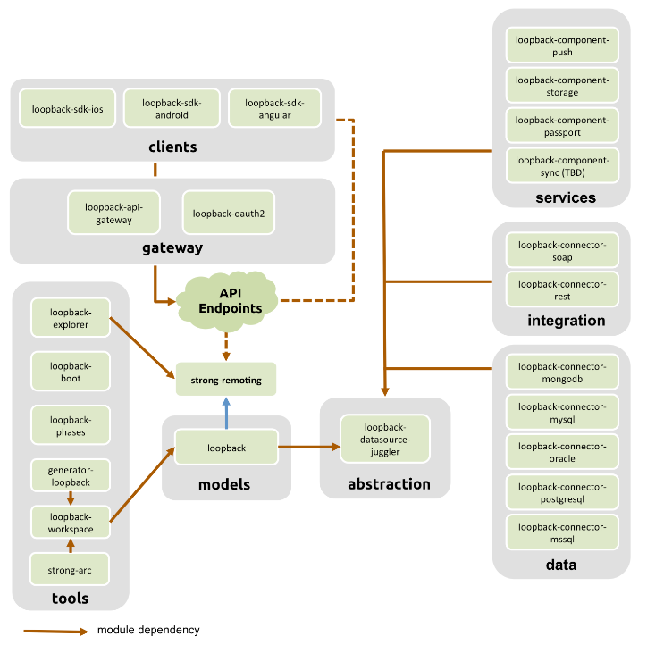
Fig. 2. LoopBack Modules

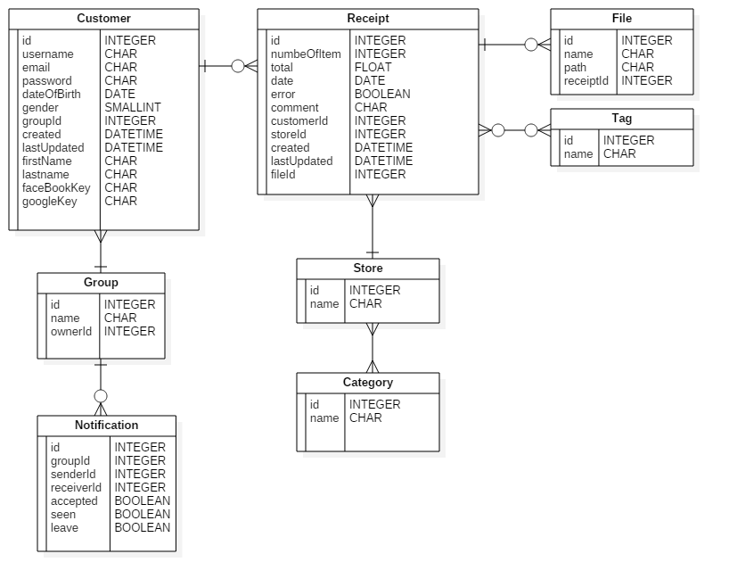

Fig. 3. Entity Diagram

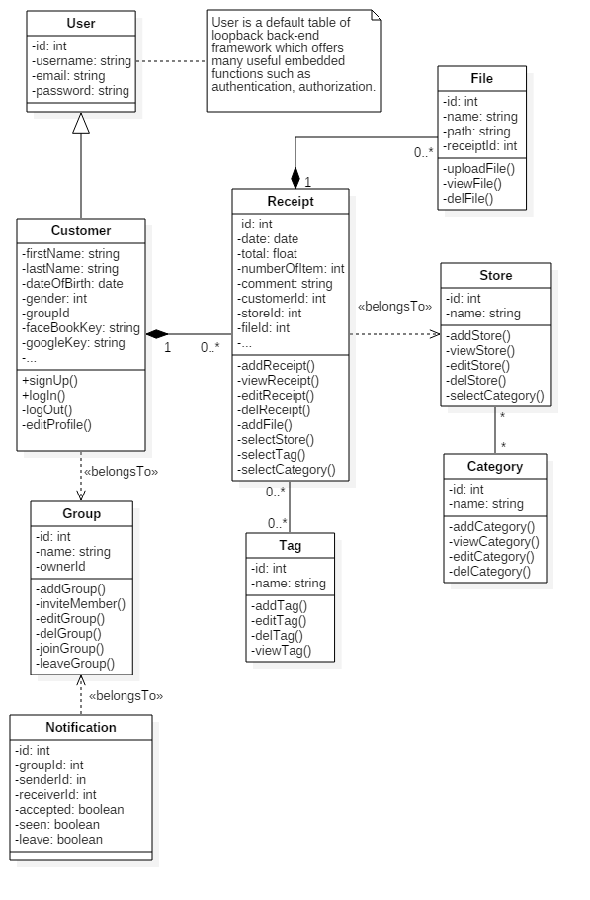

Fig. 4. Class Diagram

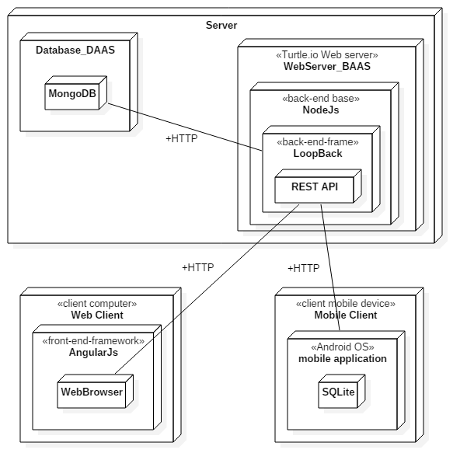

Fig. 5. Deployment Diagram

VI. CONCLUSIONS

By using Loopback framework, it is easy and quick to implement Rest API for scalability. It is also fast because is based on NodeJS and easy to implement single page application with the help of AngularJS

VII. ACKNOWLEDGMENT

The preferred spelling of the word “acknowledgment” in America is without an “e” after the “g.” Try to avoid the stilted expression, “One of us (R. B. G.) thanks …” Instead, try “R.B.G. thanks …” Put sponsor acknowledgments in the unnumbered footnotes on the first page.

REFERENCES

[1] G. Eason, B. Noble, and I.N. Sneddon, “On certain integrals of Lipschitz-Hankel type involving products of Bessel functions,” Phil. Trans. Roy. Soc. London, vol. A247, pp.529-551, April 1955.
[2] J. Clerk Maxwell, A Treatise on Electricity and Magnetism, 3rd ed., vol. 2. Oxford: Clarendon, 1892, pp.68-73.
[3] I.S. Jacobs and C.P. Bean, “Fine particles, thin films and exchange anisotropy,” in Magnetism, vol. III, G.T. Rado and H. Suhl, Eds. New York: Academic, 1963, pp.271-350.
[4] K. Elissa, “Title of paper if known,” unpublished.
[5] R. Nicole, “Title of paper with only first word capitalized,” J. Name Stand. Abbrev., in press.
[6] Y. Yorozu, M. Hirano, K. Oka, and Y. Tagawa, “Electron spectroscopy studies on magneto-optical media and plastic substrate interface.” IEEE Transl. J. Magn. Japan, vol. 2, pp.740-741, August 1987 [Digests 9th Annual Conf. Magnetics Japan, p.301, 1982].
[7] M. Young, The Technical Writer’s Handbook. Mill Valley, CA: University Science, 1989.
http://loopback.io/
android-ocr : https://github.com/rmtheis/android-ocr
LoopBack: https://loopback.io/
http://www.erudika.com/blog/2015/10/21/backend-frameworks-usergrid-loopback-para-baasbox-deployd-telepat/
http://www.restapitutorial.com/lessons/whatisrest.html

Glossary
A
ACL:
Access control list, a list associated with an object that identifies all the subjects that can access the object and their access rights. See Authentication, authorization, and permissions.
B
Buildpacks:
Buildpacks are scripts that are run when the app is deployed. They are used to install dependencies for the app and configure the environment.
.

C
D
Data source:
A data source connects with specific database or other back-end system using a connector.
E
F
G
H
I
J
K
L
M
N
O
P
Q
R
S
T
U
V
W
X
Y
Z

